**Group 25: Challenge #1 Documentation**

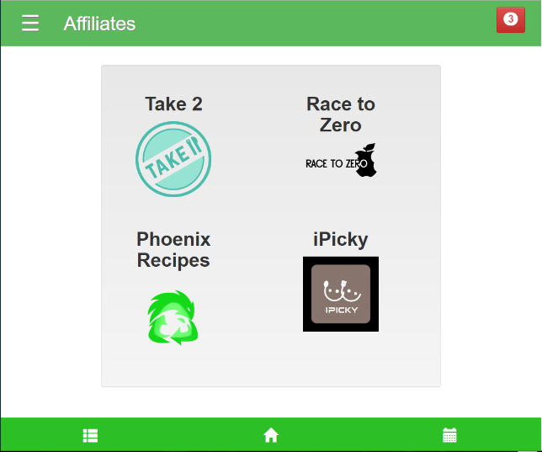**Challenge:**

Add a page of “Affiliated Apps” to your mobile web application.

**Implementation:**

We implemented this challenge feature by including a page in our web app that is accessed through our side collapsing navigation menu. The page contains the name of each of our 4 affiliate apps and their corresponding logos. Clicking on one of the logos opens up a pop-up that contains more information on the affiliate application and a link that connects them to their page.

**Reasoning:**

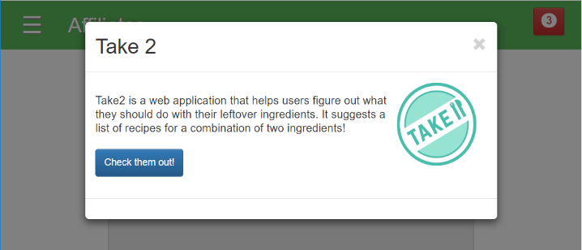We chose to affiliate with apps that in function, are different from Grocery Buddy, and can make use of the functionality that our app provides. In turn, Grocery Buddy could also make use of the functions of our affiliate apps. These include apps that make use of leftovers, provide educational information to consumers, and can take advantage of Grocery Buddy’s fridge tracking and grocery list management.

**Take 2:** Take 2 is a recipe finder app that helps users find out what kinds of meals that can make with their leftover ingredients. This could function well with Grocery Buddy’s fridge item tracker, so that users can see what items they have in the fridge, and find recipes using those items.

**Race to Zero:** Race to Zero is an educational game app that informs players about the issue of food waste. As Grocery Buddy is an app that is meant to reduce food waste, affiliating with this app would help spread awareness of food waste in Metro Vancouver. People who play Race to Zero may become interested in reducing their food waste, and could use Grocery Buddy to help achieve this.

**Phoenix Recipes:** In addition to Take 2, Phoenix Recipes also helps consumers find recipes based on the leftover food in their fridges. Grocery Buddy’s fridge item tracker would also be beneficial for people who use this app. If users require more ingredients than they have in their fridge, Grocery Buddy’s list function would help then plan what to buy.

**iPicky:** iPicky is a social app that allows users to create lists of foods that they like, as well as see lists of foods that their friends like. Using these lists, they can plan parties or meals that they can share together. Grocery Buddy’s shopping list functions can help iPicky users plan what to buy for their shared meals. Also, iPicky’s shared lists functionality, would make it easier for Grocery Buddy users to create grocery lists with other people’s preferences in mind.